

Team ***Machine***

PROPOSAL FOR RFP-QC120-12345; AUTONOMOUS ROBOT PROTOTYPE

FOR THE CONSIDERATION OF SUZAN LAST

BY

1. STUDENT &
2. STUDENT

**CONTENTS**

Necessity for Autonomous Robot 1

Proposals of Prototype Robot Designs 1

The Cleanup of Radiation and Anti-Toxic Bot (CRAAB) 1

Materials and Structure 2

Method of Movement 2

Sensory and Control Systems 2

Means of Neutralization 3

Self-Guided Toxic Element Elimination Vehicle (STEEV) 3

Materials and Structure 3

Method of Movement 4

Sensory and Control Systems 4

Means of Neutralization 4

Bill of Materials And Timeline 5

Final Considerations 6

References 6

# NECESSITY FOR AUTONOMOUS ROBOT

Radioactive and toxic waste is growing in quantity as those materials are used more and more in industry. As this continues to grow, the likelihood of hazardous spills also grows as a potential threat. Cases of this can be seen in the Fukushima Nuclear Power plant meltdown and the Mexican theft of a truck containing medical cobalt-60. The Government of Canada and the Canada Foundation for Innovation have therefore released a Request for Proposals for an autonomous robot capable of locating and neutralizing a radioactive source. Autonomous robots are needed in such cases and remote controlled systems often fail in proximity to radiation, and the levels of radiation are far too high for humans to work for extended periods of time in such environments. As a preliminary response to the RFP, we propose to build and test two prototype robot designs in the lab that will meet the following requirements stated in the RFP:

* Prototypes should be build primarily using VEX components, and may make use of additional materials, to a maximum cost of $300 CND
* The robots will be programmed to complete the required task autonomously
* The robot should limit the amount of wheel drag when turning as much as possible
* The prototype robot must locate and contact an infrared light light (simulating the radiation source) bound within a constrained region
* The robot must simulate neutralizing or disposing of the source to make the area safe for human habitation
* The robot must signal when task has been completed.

Ideally the entire task the robot undertakes should be completed quickly and efficiently.

# PROPOSALS OF PROTOTYPE ROBOT DESIGNS

The two prototype autonomous robot designs we propose to build – the CRAAB and STEEV – will meet the need specifications, constraints, and objectives of the client. These prototype designs will mimic the actions and procedures required of a full-scale robot. Either one of these concepts can be built and tested in the lab within the required time frame, once approval to go ahead has been granted.

## THE CLEANUP OF RADIATION AND ANTI-TOXIC BOT (CRAAB)

The Cleanup of Radiation and Anti-Toxic Bot, or CRAAB (Fig. 1), is a functional prototype for use in developing an autonomous vehicle for disposal and safe handling of hazardous materials. This prototype instead operates using infrared sources but the processes themselves are transferrable for detecting different attributes, such as radiation. The CRAAB [see Figure 1] does this by driving to the source with its two large rear wheels (**10**) and then using sweeping arms (**7**) to force the object into a containment mounted on its front. This process is powered by the rear-mounted battery pack (**3**). [*you have not made it clear what these bracketed numbers refer to…]*

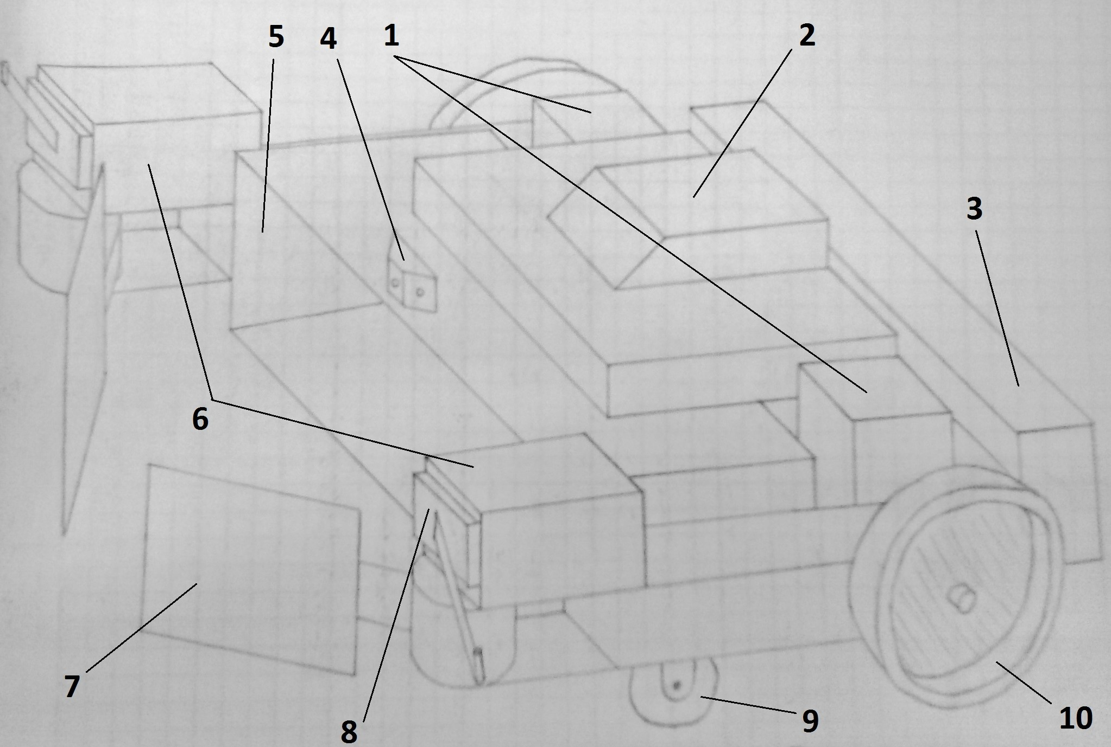

**Figure 1: Perspective of the CRAAB autonomous cleanup robot with pointers for part identification [*this needs a key*]**

MATERIALS AND STRUCTURE

The CRAAB is constructed primarily from the VEX kit Claw-Bot components [1] with the addition of approximately 0.25 square meters of rigid sheet material, cardboard or metal, which are formed into the sweeper arms and storage compartment (**5**). The design also utilizes two free-wheeling castors

(**9**) to support the front of the vehicle, and three infrared sensors.

METHOD OF MOVEMENT

The robot’s movement is performed by two wheels, directly driven by two motors (**1**), mounted in the rear-center of the chassis. These wheels not only drive the robot forward, but also provide it with a very small turn radius by reversing and advancing the opposing wheels to rotate the vehicle in place. The front portion of the robot is supported through these processes by the castors, which also eliminate the issue of wheel drag by spinning freely into the necessary direction.

SENSORY AND CONTROL SYSTEMS

The processes of the robot are exclusively controlled through automated systems embedded in the VEX controller (**2**). The controller directs the robot operations based on information received from the three fixed angle infrared sensors (**4**). This process begins with a stationary rotational scan, which ceases upon location of the source. The CRAAB then advances towards the source, continuously confirming that it has not deviated from its initial path. Should the robot contact any foreign obstacle, the bumper switches (**8**) mounted at the front of the chassis will indicate to the controller that the vehicle must reverse and adjust its course accordingly. This allows the vehicle to operate around obstructions quickly and effectively.

MEANS OF NEUTRALIZATION

To simulate the eventual neutralization process of the vehicle, once the CRAAB has reached the infrared source, it aligns itself with the source lying directly in from of the storage compartment, between the sweeping arms. The two sweeping arm motors (**6**) then swing the sweeping arms inward, forcing the source into the front-mounted compartment and seal it. The completion of this process is signaled to the controller when the source compresses a button mounted in the rear of the compartment. The source, then contained, may be freely transported to a safe location for disposal.

## SELF-GUIDED TOXIC ELEMENT ELIMINATION VEHICLE (STEEV)

The Self-Guided Toxic Element Elimination Vehicle (STEEV) is a simple prototype designed to neutralize the infrared source by containing it within itself. STEEV is equipped with a descending ring arm that can be placed over the source and retracted into the chassis. Once STEEV is holding the radiation source within itself, it is free to move about, towing the source with it (Fig. 2). ✓

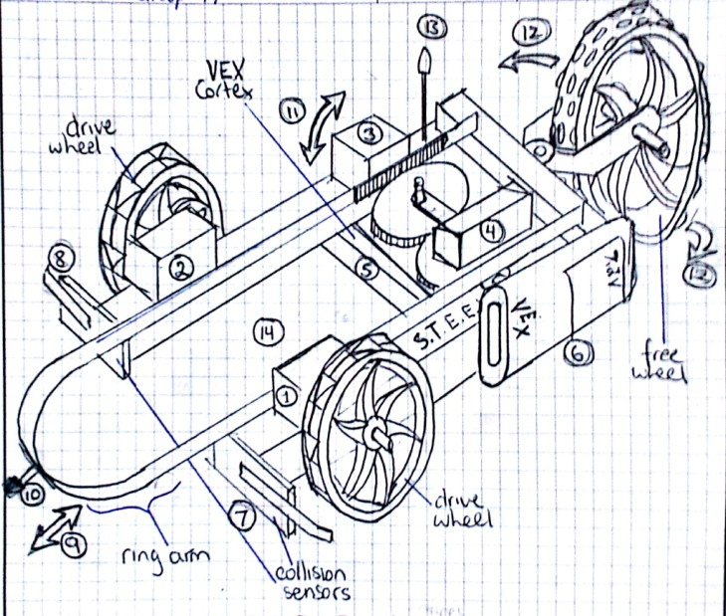

**Figure 2: Perspective view of STEEV with knobbed castor configuration**✓

MATERIALS AND STRUCTURE

This prototype will be constructed using parts from the VEX ClawBot Kit [1]. This kit includes 4” wheels, 2 limit switches, 4 motors, a VEX Cortex microcontroller, battery, and various steel structural components and connectors. Parts are also included from the VEX Advanced Gear Kit [2], and one VEX 5” knobbed tire [3] is required for the knobbed castor configuration. Four infrared sensors will be positioned at the front of the vehicle to guide it to the infrared source. One LED beacon will be required to indicate task completion.

METHOD OF MOVEMENT

STEEV is driven by two individually controlled drive wheels located at the front end of the vehicle. Each drive wheel is powered by its own motor (①, ②), so running the wheels in opposite directions from one another will allow STEEV to pivot around its front axis with almost no turning radius. A third wheel is mounted at the back of the vehicle as a castor, providing balance. This castor can be swapped between a smaller wheel for tighter maneuvering on smoother surfaces, and a larger, knobbed wheel for rougher areas.

SENSORY AND CONTROL SYSTEMS

To locate the infrared source, STEEV is equipped with an infrared sensor array (⑩), built onto the front of the ring arm. Front-mounted limit switches (⑦, ⑧) will serve as collision sensors to indicate when the vehicle hits the side of the constrained search area. The LED beacon (⑬) indicates when the vehicle has located and neutralized the infrared source.

All of STEEV’s functions will be controlled by the VEX 2.0 Cortex (⑤), located underneath the chassis at the back of the vehicle. A 7.2 volt battery (⑥) will serve as the power supply.

MEANS OF NEUTRALIZATION

STEEV simulates neutralization by containing the toxic source within itself. The ring arm can be raised and lowered by a quadrature encoded motor (③), and also extended and contracted by a separate quadrature encoded motor (④). The range to which the ring arm can be raised and lowered (⑪) and extended and contracted (⑨) will be monitored by the quadrature motors, so the ring arm will not sustain damage from being forced against other parts of the vehicle. While STEEV is locating and approaching the infrared source, the ring arm is fully extended and raised to maximum height.

To contain the source, STEEV lowers the ring arm and draws the infrared source into itself (Fig. 3).

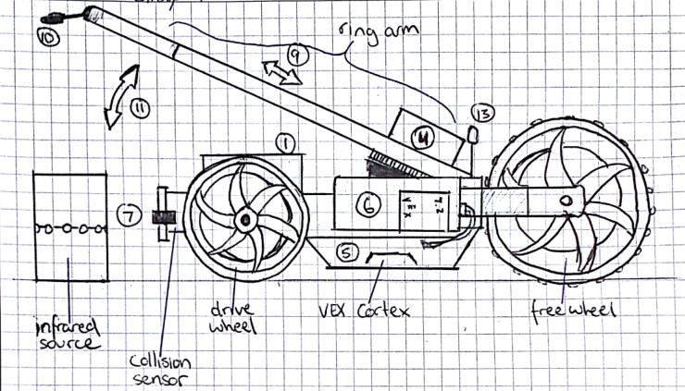

**Figure 3: Cross section of STEEV with extended and raised ring arm, knobbed castor configuration**✓

## BILL OF MATERIALS AND TIMELINE

Both robot designs are built using complete VEX kits containing the parts for the ClawBot [1], the Advanced Gear Kit [2], and the 5” Wheel 4-Pack [3], bringing the total cost of either configuration to

$240.00. The components of these kits are used to varying degrees by each design. Additional parts used are outlined in the Bill of Materials below (Table 1), all remaining under the total budget of

$270.00.✓

|  |  |  |
| --- | --- | --- |
| *Table 1: Bill of Materials* ✓ | | |
| Components | **The CRAAB** | **STEEV** |
| Castor Wheels | 2 | 0 |
| Sheeting Material | 0.25 m2 | 0 m2 |
| Infrared Sensors | 3 | 4 |
| LED beacons | 1 | 1 |
|  |  |  |
| Total Cost (incl. VEX kit) | $257.00 | $242.50 *bold your totals* |
| Remaining Budget | $13.00 | $27.50 |

Both designs follow the same [10 week] timeline ~~as laid out by the laboratory sessions scheduled by~~ ~~the University of Victoria Engineering 120 design laboratory technicians.~~ [*don't refer to your classes; maintain the “workplace” rhetorical situation*] This process is illustrated ~~below✗ (~~ in Table 2).

[*Write a brief paragraph describing what each milestone entails, or build clear descriptions of tasks into your Gantt chart*]

|  |  |  |  |  |  |  |  |  |  |  |
| --- | --- | --- | --- | --- | --- | --- | --- | --- | --- | --- |
| *Table 2: Timeline for Prototype Development* ✓ | | | | | | | | | | |
|  | Week  1 | Week  2 | Week  3 | Week  4 | Week  5 | Week  6 | Week  7 | Week  8 | Week  9 | Week  10 |
| Obtain VEX kit |  |  |  |  |  |  |  |  |  |  |
| Familiarize with ROBOTC interface |  |  |  |  |  |  |  |  |  |  |
| Beginner circuit  design |  |  |  |  |  |  |  |  |  |  |
| Beginner infrared  sensor design |  |  |  |  |  |  |  |  |  |  |
| Research designs and  develop sketches |  |  |  |  |  |  |  |  |  |  |
| Milestone 1  *What is this??* |  |  |  |  |  |  |  |  |  |  |
| Structural design  *Is this milestone 2?* |  |  |  |  |  |  |  |  |  |  |
| Test locomotion and  neutralization |  |  |  |  |  |  |  |  |  |  |
| Work on Milestone 3  *Be more specific* |  |  |  |  |  |  |  |  |  |  |
| Test Milestone 3 |  |  |  |  |  |  |  |  |  |  |
| Work on Milestone 4 |  |  |  |  |  |  |  |  |  |  |
| Test Milestone 4  (Final Test) |  |  |  |  |  |  |  |  |  |  |

# FINAL CONSIDERATIONS

These design concepts for two autonomous hazardous waste elimination robots have been crafted to meet objectives and constraints outlined in the RFP received from the Government of Canada and the Canada Foundation for Innovation. Both designs fall well within budget and can quickly and effectively locate and neutralize a simulated radioactive source. Either of these designs would therefore prove to be a valid prototype candidate to be developed to meet the specific need of the request for proposals. We look forward to receiving your feedback on these design concepts, and can start the design and testing process as soon as the optimal design has been chosen and approved.

# REFERENCES

1. VEX Robotics. (2014). *VEX Robotics ClawBot Kit* [Online]. Available: <http://www.vexrobotics.com/276-2600.html>[Feb. 18, 2014].
2. VEX Robotics. (2014). *VEX Robotics Advanced Gear Kit* [Online]. Available: <http://www.vexrobotics.com/vex/products/accessories/motion/276-2184.html>[Feb. 18, 2014].
3. VEX Robotics. (2014). *VEX 5” Wheel (4-pack)* [Online]. Available: <http://www.vexrobotics.com/vex/products/accessories/motion/276-1498.html>[Feb 18, 2014].

*[this lacks research on extant designs that support and validate your approaches…]*